

How CBCT 3D X-rays Improve Diagnosis and Treatment at Butler Medical Imaging. (08) 9544 3999

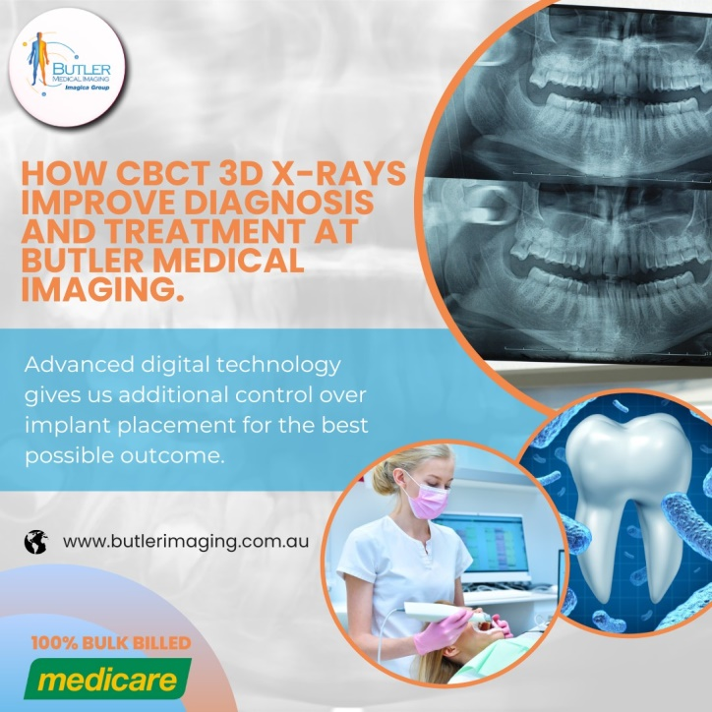Cone Beam Computed Tomography (CBCT) 3D X-rays have revolutionized the field of dental imaging and oral healthcare, offering a far more comprehensive picture of a patient’s oral anatomy than traditional 2D X-rays. This cutting-edge technology enables dentists and specialists to detect critical issues that might otherwise remain hidden, ensuring that diagnosis and treatment plans are more accurate, efficient, and personalized. At Butler Medical Imaging, we are proud to utilize advanced [CBCT](https://butlerimaging.com.au/dental-cbct/) technology to provide our patients with the highest level of care and precision.

## What is CBCT 3D Imaging?

CBCT is a specialized type of X-ray machine used in dental and maxillofacial (jaw and facial) imaging. Unlike conventional 2D X-rays, CBCT creates a three-dimensional image of your teeth, soft tissues, nerve pathways, and bone in a single scan. This 3D imaging offers a more detailed, panoramic view of your oral and facial structures, allowing dental professionals to visualize areas that may be obscured or difficult to see with standard X-rays.

[CBCT](https://butlerimaging.com.au/dental-cbct/) works similarly to a hospital CT scan but with significantly lower radiation levels. While the process is as quick and straightforward as traditional X-rays, the resulting images provide a wealth of additional information, enabling clinicians to make well-informed decisions about diagnosis and treatment. It’s especially useful for complex dental cases where traditional imaging might not reveal the full extent of an issue.

## How Does CBCT Work?

The process of capturing a CBCT scan is simple and non-invasive. The patient stands or sits in the machine while the scanner rotates around their head, taking a series of detailed images from multiple angles. The entire process takes just 10 to 20 seconds, making it fast and convenient. The images are then processed to create a 3D model of the patient’s oral anatomy, which can be viewed from any angle and in great detail.

One of the key advantages of CBCT imaging is that it eliminates the need for uncomfortable intraoral films used in traditional [X-rays](https://butlerimaging.com.au/dental-cbct/). Patients can remain relaxed and comfortable throughout the scan, with no film or sensors placed inside the mouth. The device also uses a low dose of radiation, making it safe for patients of all ages, including children.

## Benefits of CBCT Imaging

CBCT technology offers numerous advantages over traditional 2D X-rays, making it an indispensable tool in modern dentistry and oral surgery:

* **Detailed Visualization:** CBCT provides highly detailed 3D images, allowing clinicians to visualize the entire oral and facial structure in much greater detail than conventional X-rays. This is particularly important for detecting issues like impacted teeth, infections, and bone loss that might not be visible on 2D images.
* **More Accurate Diagnosis:** With the ability to see teeth, bones, and soft tissues in three dimensions, dental professionals can make more accurate diagnoses. [CBCT](https://butlerimaging.com.au/dental-cbct/) helps in identifying conditions such as tumors, fractures, and abnormalities in the jaw and facial bones.
* **Improved Treatment Planning:** Whether you’re undergoing orthodontic treatment, dental implants, or a root canal, CBCT imaging ensures that your dentist has all the information needed to plan the most effective treatment. For example, in implant dentistry, CBCT scans allow clinicians to assess bone density, proximity to nerves and sinuses, and the exact location where an implant should be placed.
* **Reduced Radiation Exposure:** Although CBCT scans use radiation, they often replace the need for multiple traditional X-rays, thus reducing your overall radiation exposure. In many cases, a single CBCT scan provides as much information as several 2D X-rays would, making it a safer option in the long run.
* **Enhanced Patient Comfort:** Since there’s no need to place uncomfortable films or sensors in the mouth, patients find CBCT scans more comfortable and less invasive. The quick scan time also minimizes discomfort, particularly for patients with sensitive gag reflexes.

## How CBCT Improves Diagnosis and Treatment

CBCT technology enhances the accuracy and effectiveness of diagnosis and treatment in a variety of dental procedures. Here’s how it benefits some common treatments:

* **Dental Implants:** For patients requiring [dental implants](https://butlerimaging.com.au/dental-cbct/), CBCT provides critical information about the volume and density of the jawbone. This helps determine whether a patient has sufficient bone to support an implant or if bone grafting is necessary. CBCT also allows precise placement of implants, reducing the risk of complications and improving long-term success rates.
* **Root Canal Treatment:** CBCT is extremely helpful in root canal procedures, as it allows dentists to visualize the intricate network of root canals within a tooth. This ensures that all canals are located and treated, reducing the risk of infection or failure after the procedure.
* **Wisdom Teeth Extraction:** When wisdom teeth are impacted or located near vital structures like nerves, CBCT provides detailed images that help oral surgeons plan the safest and most effective extraction method. Identifying hidden or curved roots in advance minimizes the risk of damage to surrounding tissues.
* **Orthodontics:** Orthodontists use [CBCT](https://butlerimaging.com.au/dental-cbct/) imaging to assess the alignment of teeth and the position of the jaw, ensuring that braces or aligners are applied with maximum precision. The 3D images allow for better treatment planning and predictability of outcomes.
* **TMJ (Temporomandibular Joint) Disorders:** CBCT scans offer a clear view of the jaw joints and surrounding bones, aiding in the diagnosis and treatment of TMJ disorders. By assessing the anatomy of the joint, dentists can recommend the most appropriate treatment options.

## Why Choose Butler Medical Imaging?

We are local and a privately-owned medical clinics that offers the highest quality medical and Imaging Services in the [Butler](https://butlerimaging.com.au/appointment/) Medical Imaging region. We are the leaders in Bulk Billing with the real benefit of no ‘Out of Pocket’ expenses for you.

## Your Next Step

Please ensure that you have your Medicare card and referral with you and pop into our location for your consultation. If you have any questions at all, please feel free to contact us at [+61 8 9544 3999](https://butlerimaging.com.au/appointment/) as we are here to help.